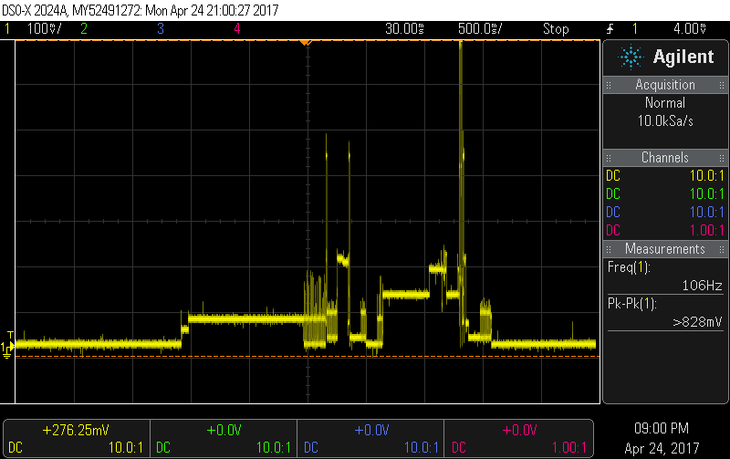

Tag before: out of scope , so the peak value is smaller than after

